Beta Defence - Further Development

William Cheung
WilliamCheung2004@gmail.com

Contents
1.0 2
Bug Fixing from previous version 2
Issue 1 : Background Loading 2

1.0

Bug Fixing from previous version
Previously on the development of Beta Defence I had completed a working basic prototype on what my game should have that including : some enemies that will attack the player, a working turret the player can control and other basic mechanics such as the enemies moving towards the player.
The player currently is able to shoot and being able to take damage as well as being able to gain some currency., this being with an addition of a few bugs of course, so I will attempt to fix them here first before tackling the main game.
First of all though, it has been some time before I had last used and modified the game so there has been some changes to Replit the free online IDE which I had used previously to design and test the game. However as of currently, Replit now had some limitations for free users, therefore, I have now decided to switch to using Visual Studio Code.

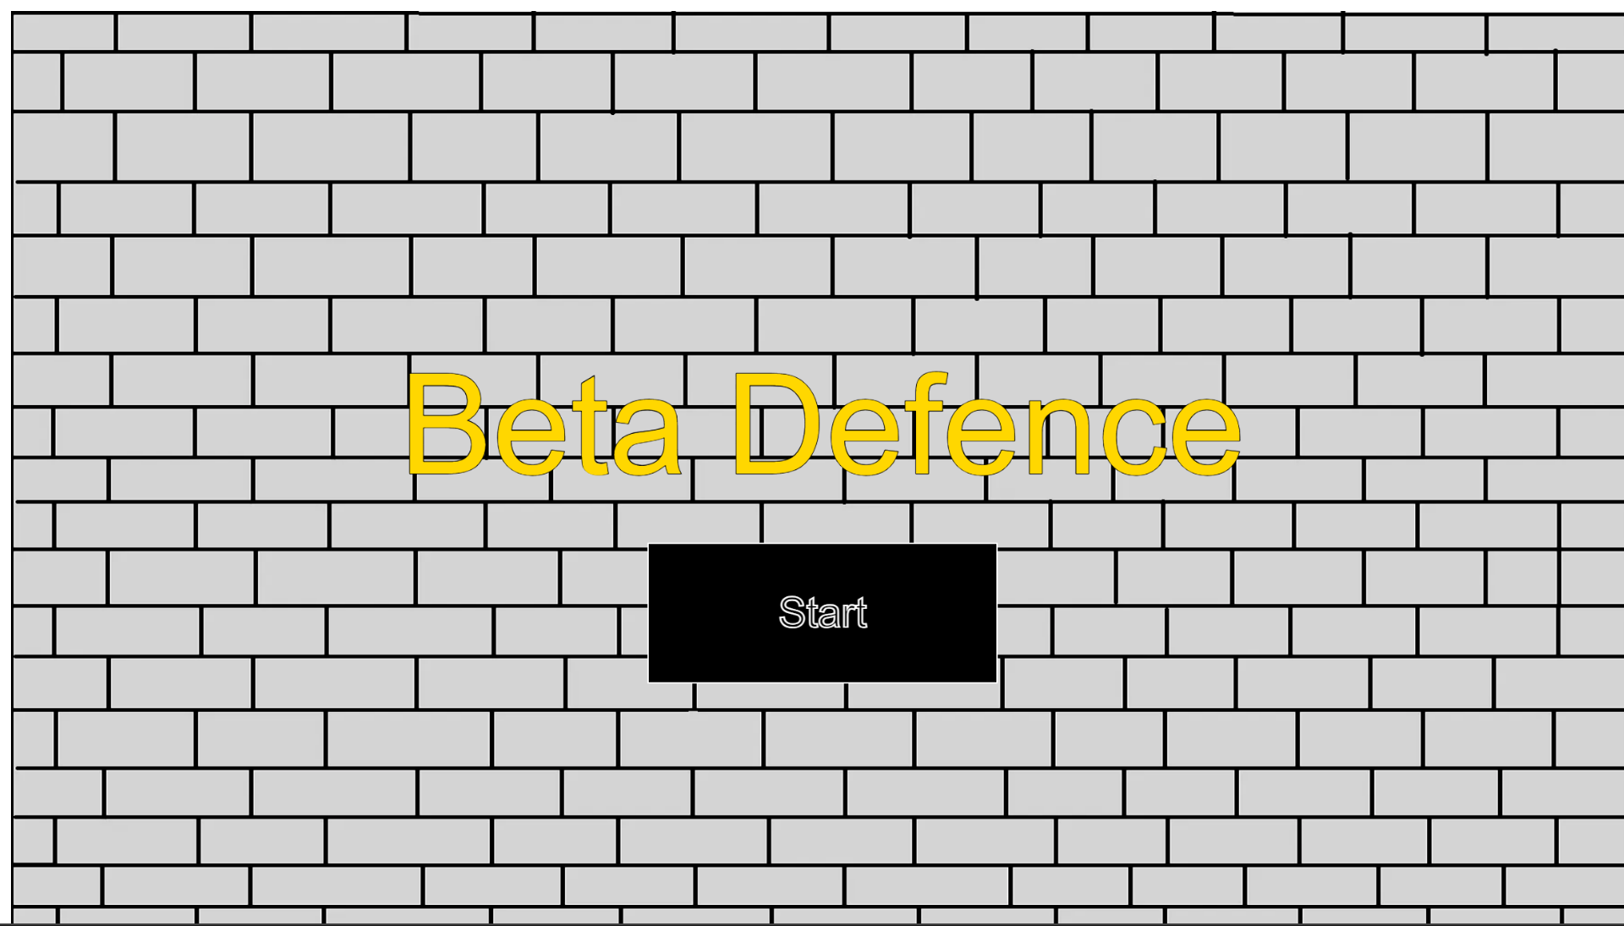

Issue 1 : Background Loading
When loading the game, everything seemed to work fine as before except for one small issue. it immediately caught my attention that for some reason now, there was a small white border around my game and after some testing of the game, this affected the whole game and not just the title screen.
I used a black border for the screenshot here to make this easier to see. I am not sure why this has happened as previously the game had worked flawlessly before so perhaps I would just need to update some of the libraries.

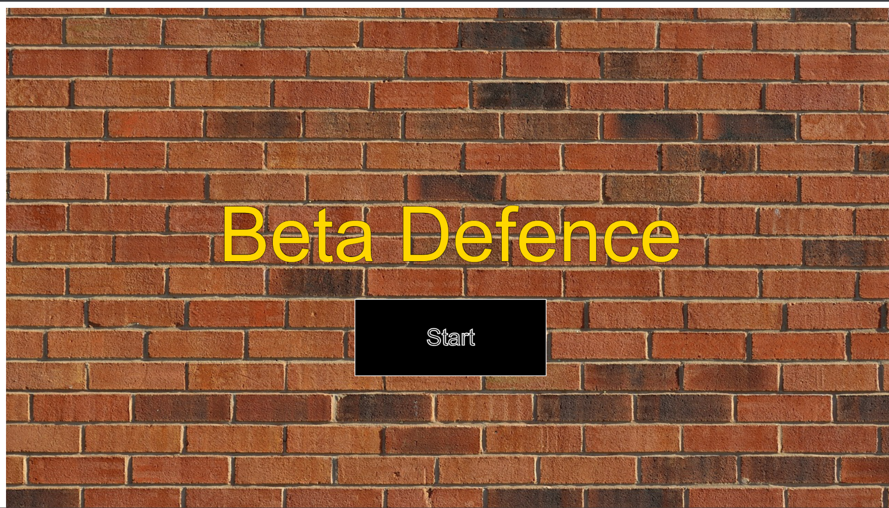
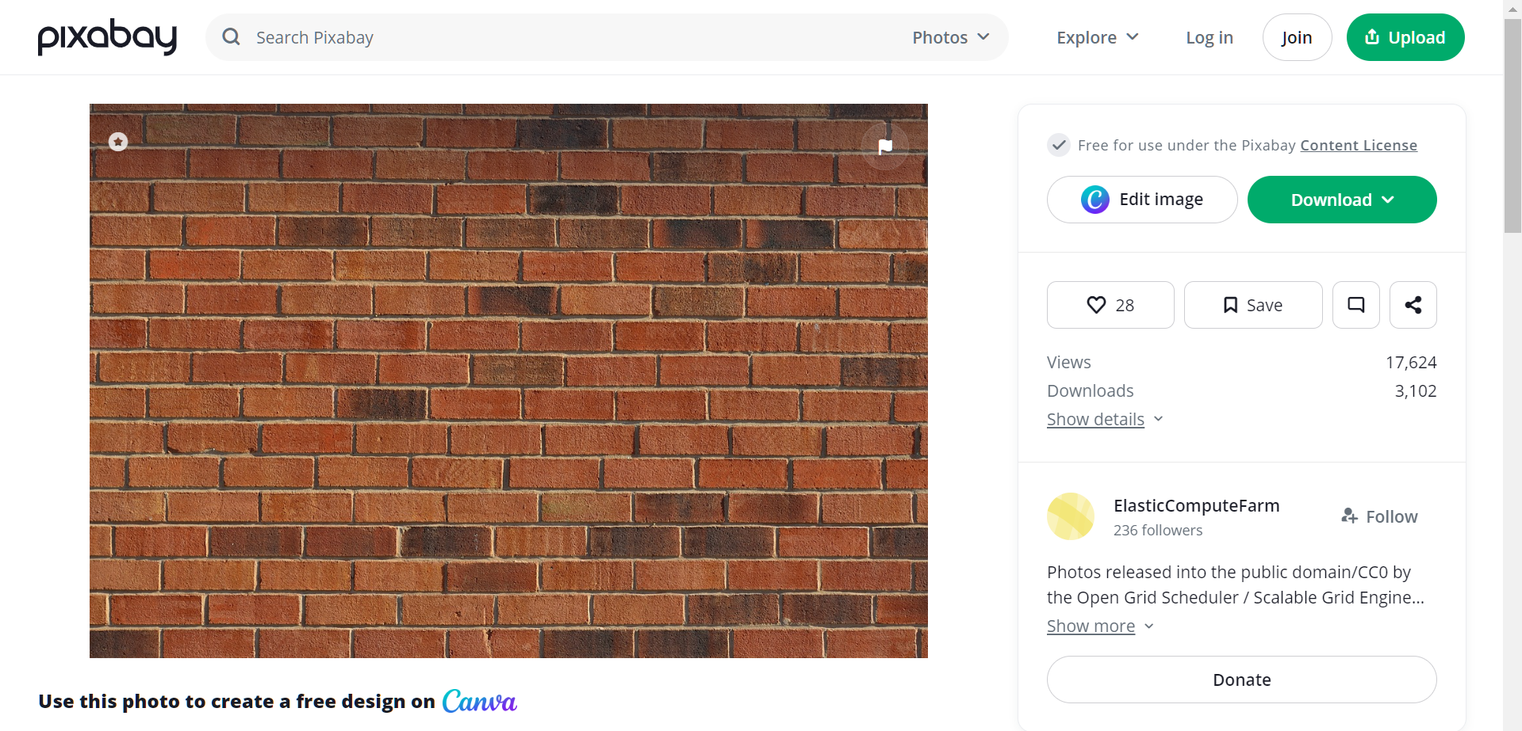
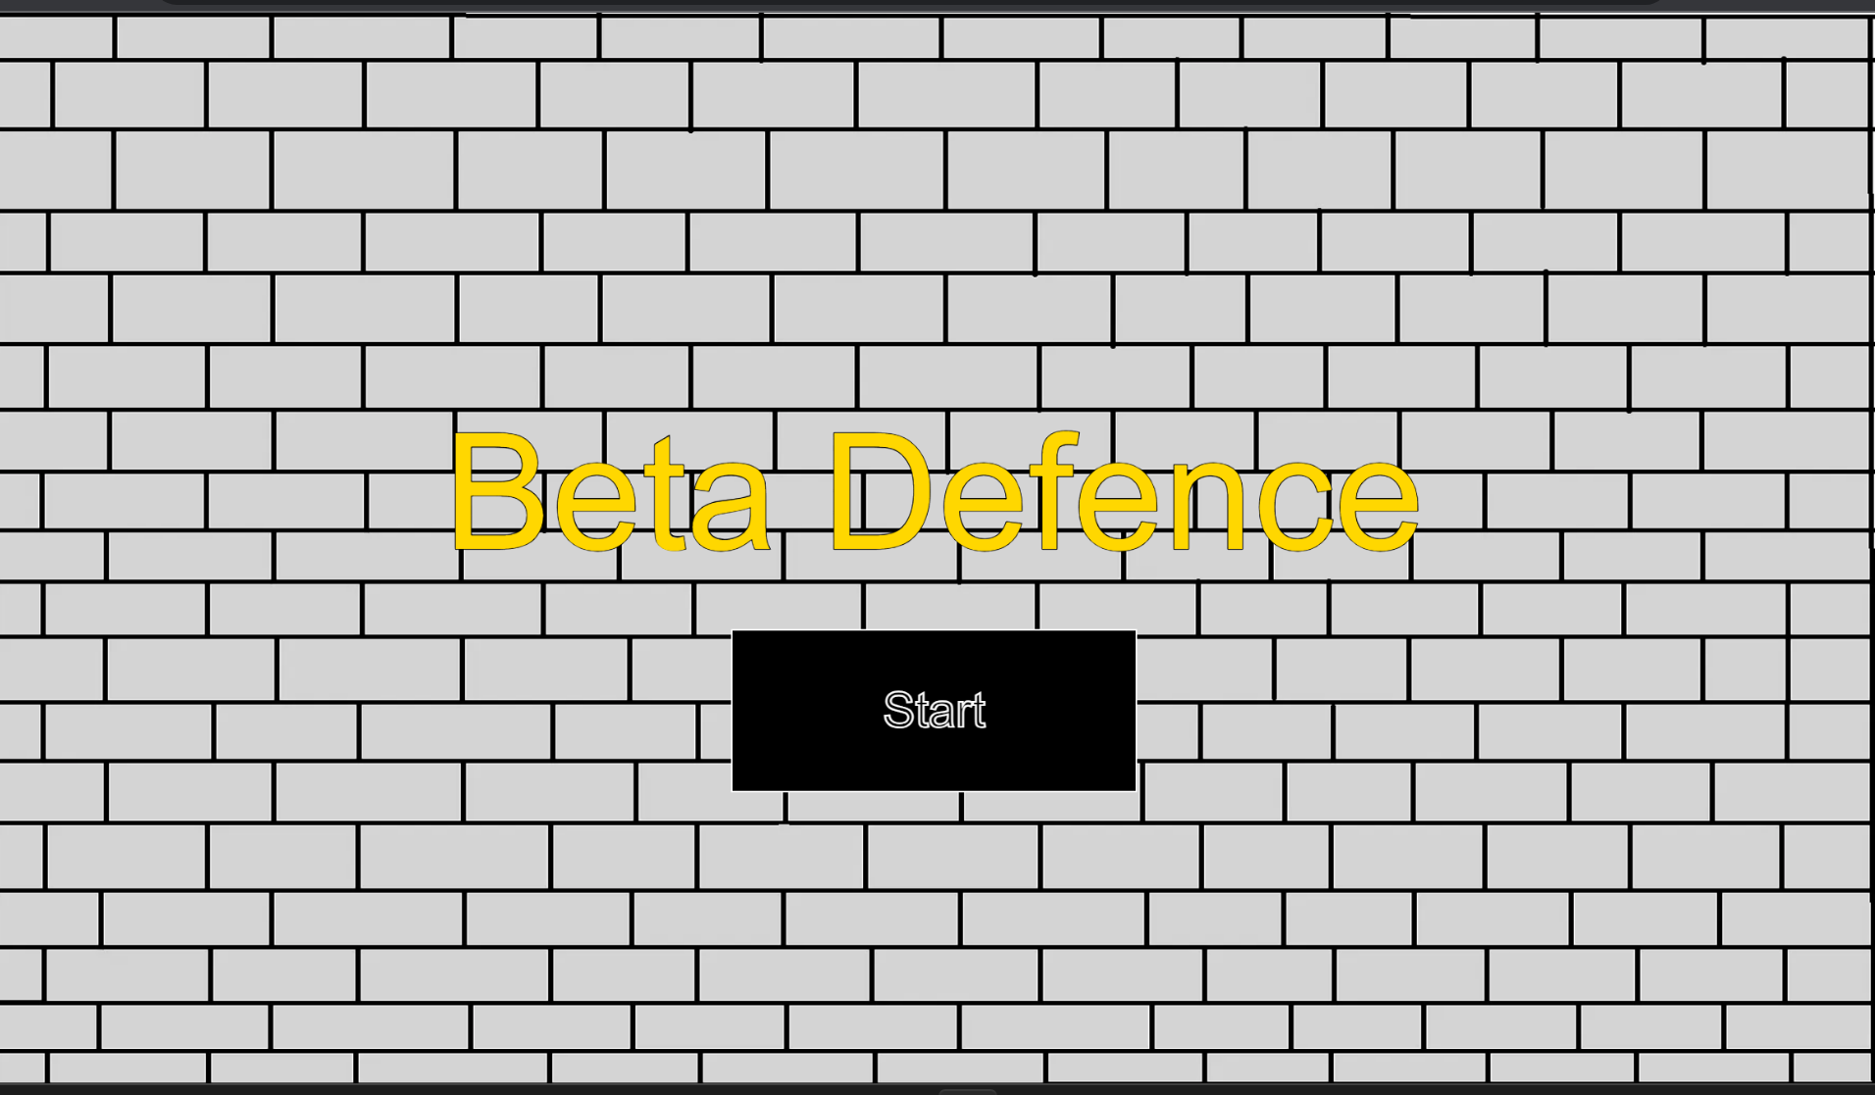
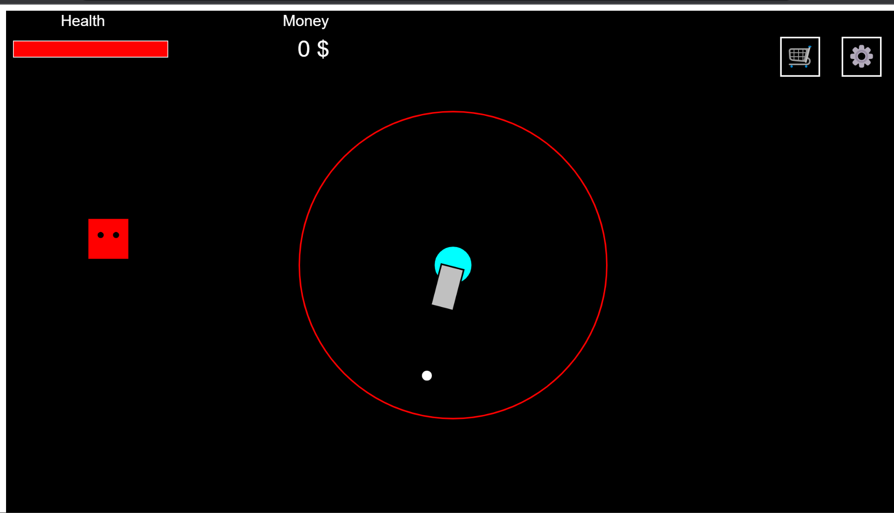
When adding the image to the game, replacing the old background with the test image I downloaded from the website above, I found the same problem had occurred, so the issue here clearly wasn’t the fault of the background image but very evidently something else here was causing the issue.

So, I used a royalty free image from (ElasticComputeFarm, 2023) which provided a full image of a background I can use to test.

Perhaps the issue may be due to the background image itself. Since I created the main background myself within the Window’s paint app, the background may have not scaled properly within the game since I created the image within a small canvas, thus may of causing this error, so trying a new properly rendered image may work.gy
I replaced the old p5 library with the current newest one, unfortunately , this did not solve the current problem though, updating the library may be useful for later use for newer functions and bug fixes.
src="https://cdnjs.cloudflare.com/ajax/libs/p5.js/1.7.0/p5.js" type="text/javascript">

margin: 0
padding : 0

Thankfully, this seemed to have fixed the issue for the background image for the title screen and backgrounds for the game in general, but there were just a few more issues I wanted to fix before starting the game.
After some reading around on the internet, I found some people having similar issues with the background image not fully rendering on the screen, to which some other people suggesting by resetting the page to default values in order to fix this. In recent programming I have learnt how to program this before for html page design through using CSS.
Within the CSS file, I added margin and padding with the values of 0 in order to reset the page so hopefully my background image will then fully cover the whole screen like intended.

Looking at this now, it would have been clearer a bit earlier if I had remembered that this background error also occurred within the game and not just the title of the game .

Issue 2 : Screen Resizing – Responsive Design

Over the course of University, I learnt the importance of apps requiring some flexibility in terms of what devices it can be run on, this includes making sure the game works on different screen sizes, currently, my game does not do that so I will try tackle that here.
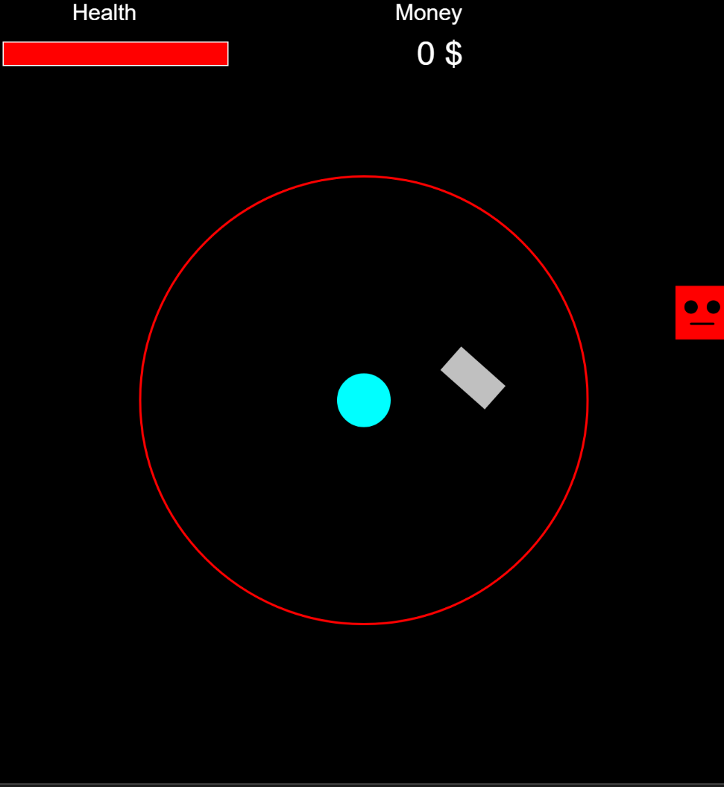

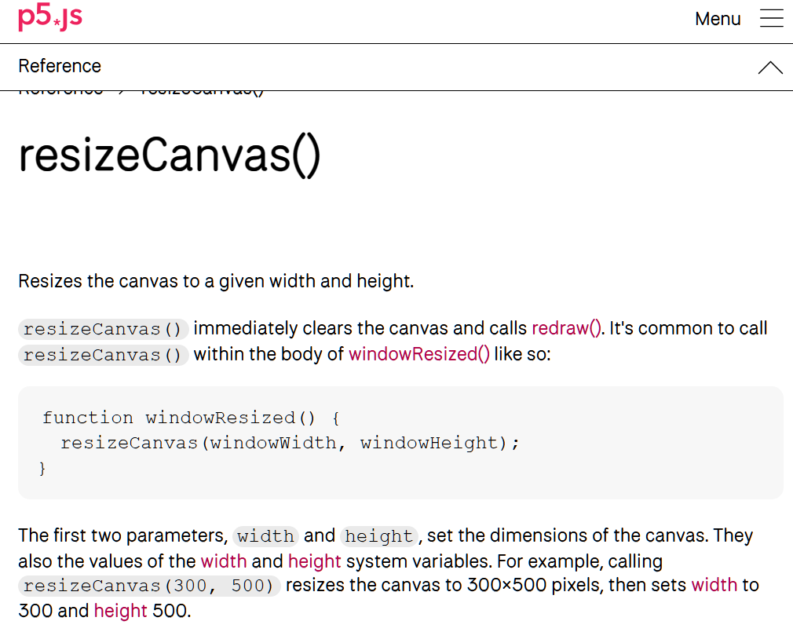
After some time of researching, it seems p5 has a way to resize objects on a canvas when screen size is changed – simply what I need in this situation.
So, to make this game “responsive” I would need a way to know when the user changes the screen size, to then re-adjust where everything is drawn onto the canvas – this should update every time the user changes screen size.
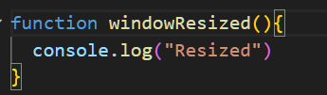
Firstly I wrote the function and added a quick test to see if resizing the screen actually works .

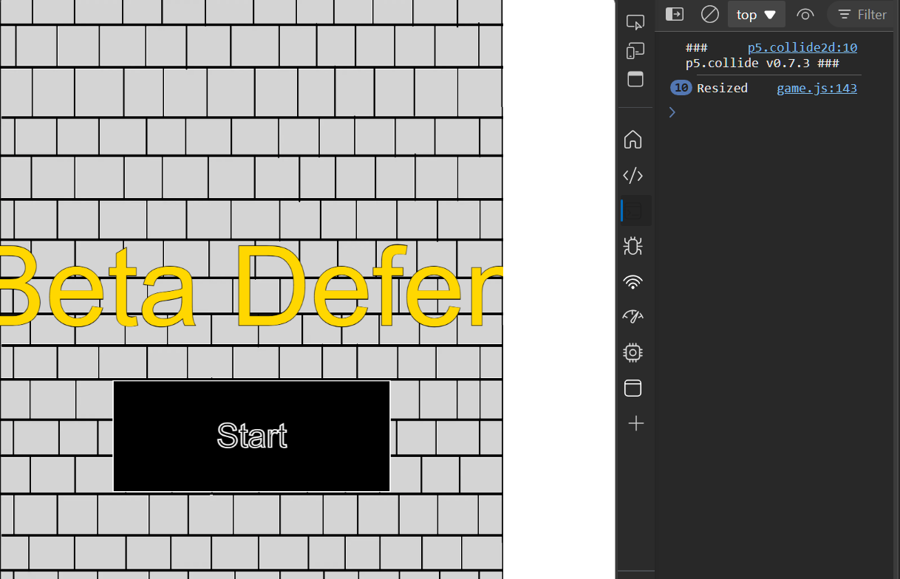
And so it did, and so the next step would be writing a function in this to update each object on the canvas whenever the screen is resized.

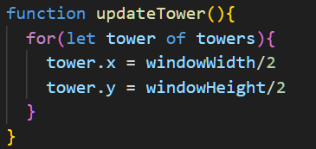

Starting with the tower, for each tower object – update the towers position each time the windowReized() function is called to a new position based on the current screen’s width and height.
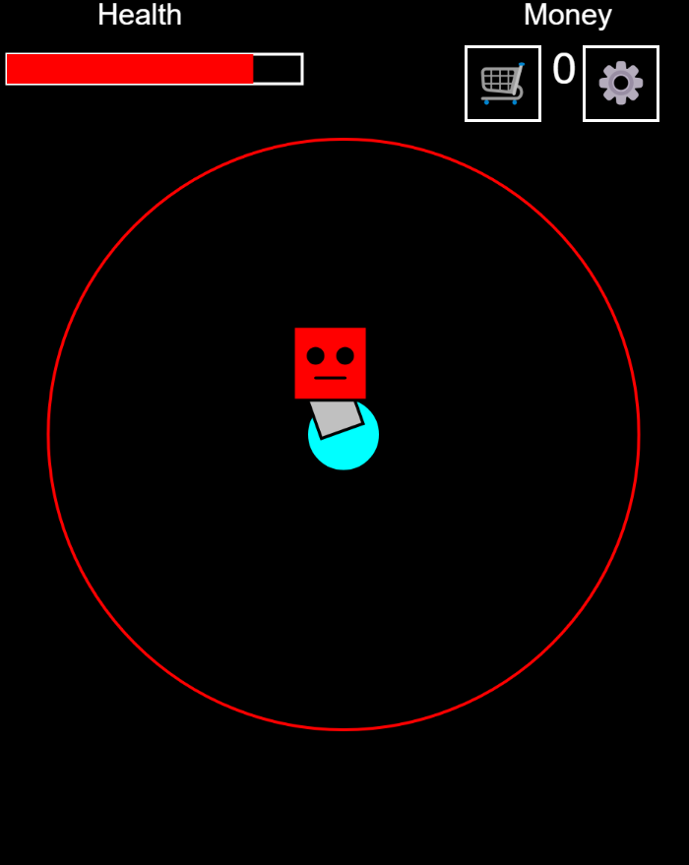
Nice, this seemed to have worked well, now I would just have to implement this for every single object ….
But of course things aren’t as easy as it seems, the next object I worked on adjusting was the tower range, problem was, the range wasn’t adjusting for some reason?
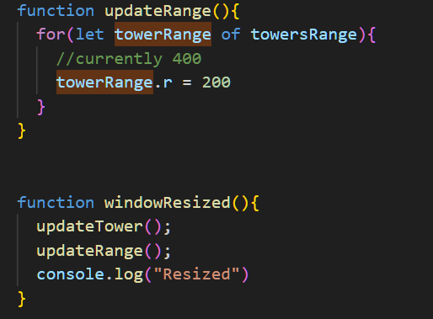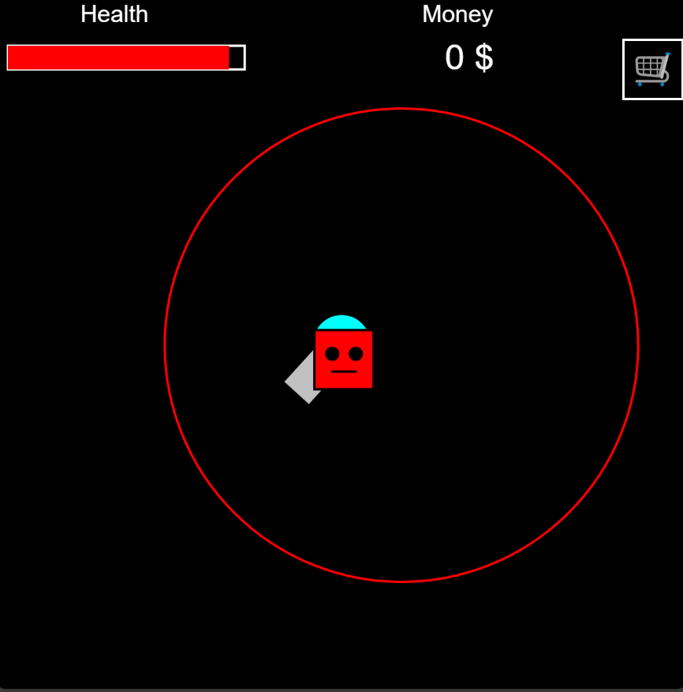
Well that didn’t work. So I looked at how my tower was drawn and noticed:
The tower wasn’t drawn with the radius property, so I added this in.
This didn’t change the resizing though, therefore it had to be within the tower property itself.
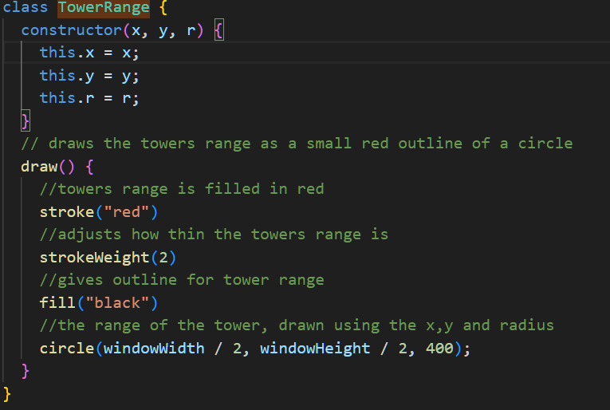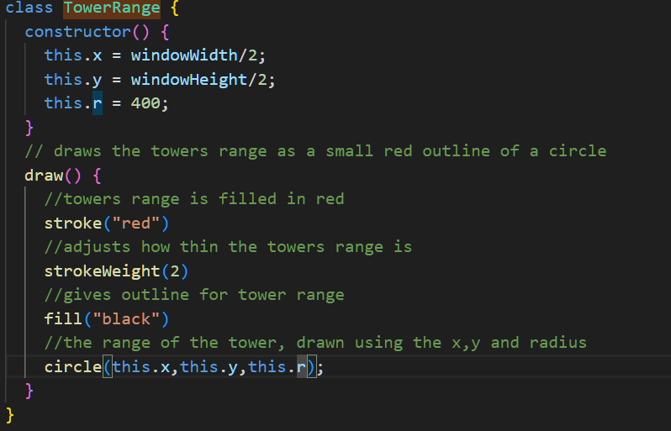
Due to my previous inexperience in programming I didn’t know how constructors worked, so it seems this is where the issue was : the constructor has parsed in values – currently x , y , r which didn’t really seemed to be used, I looked over at the structure of my tower code and how it worked, realizing that I had to set the values in order for them to be updated later, so I changed this code from left to right – old code to newer code.
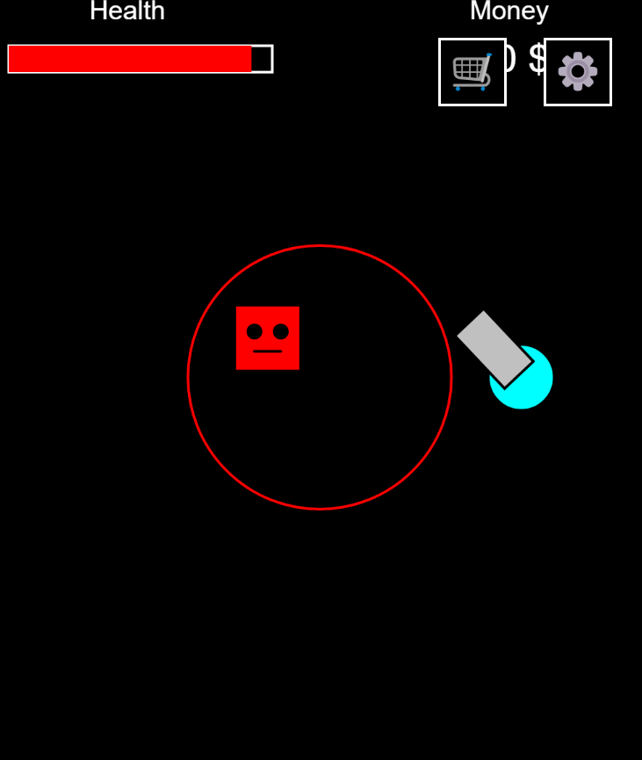
The range now successfully is resized, but shouldn’t this be connected to the tower? The range should also scale down based on the window size, so ill try make that happen.
I noticed since the tower and towers range (though should be part of the same object but past programmer me decided to make them separate) I could shorten my code by using the coordinates of the tower itself – hopefully this doesn’t break anything but I can revert this later.

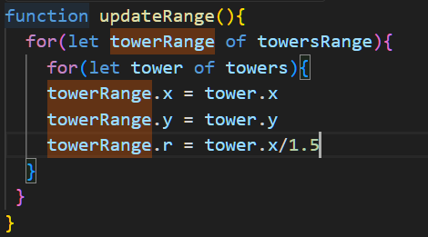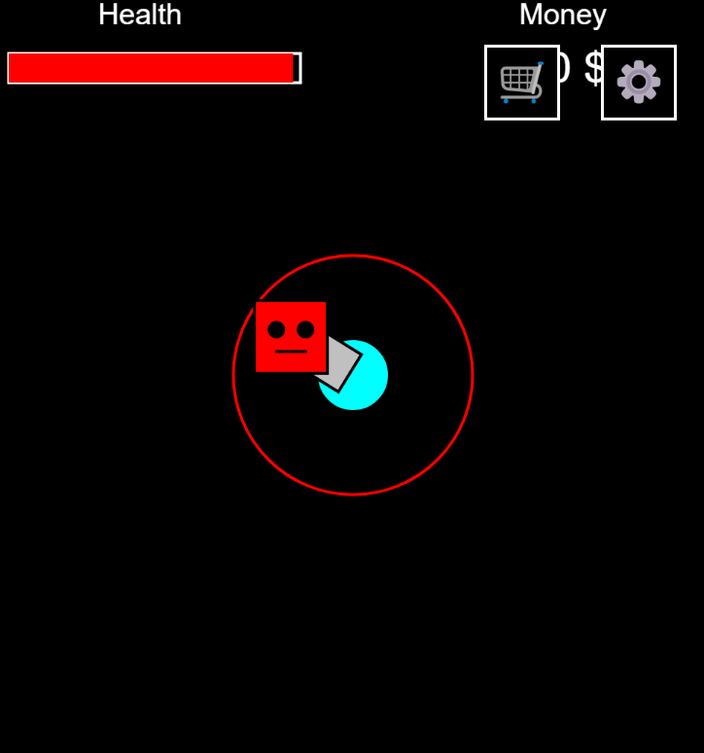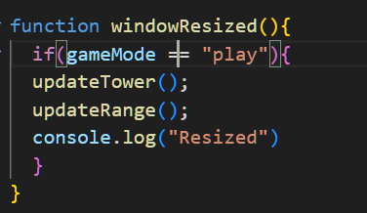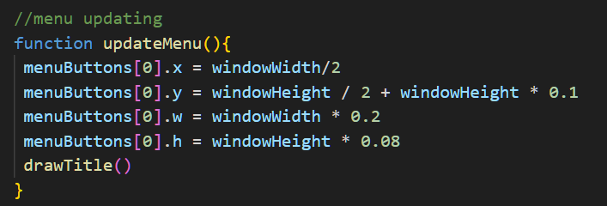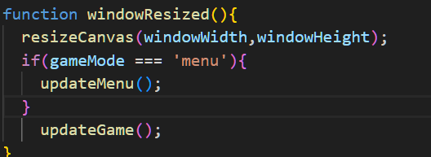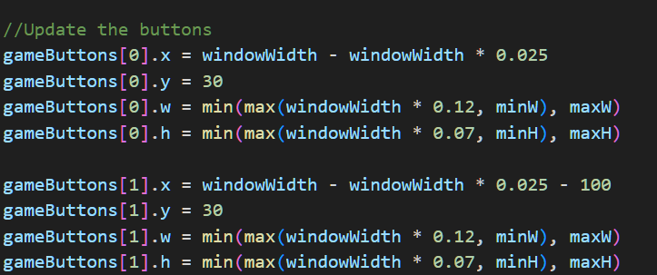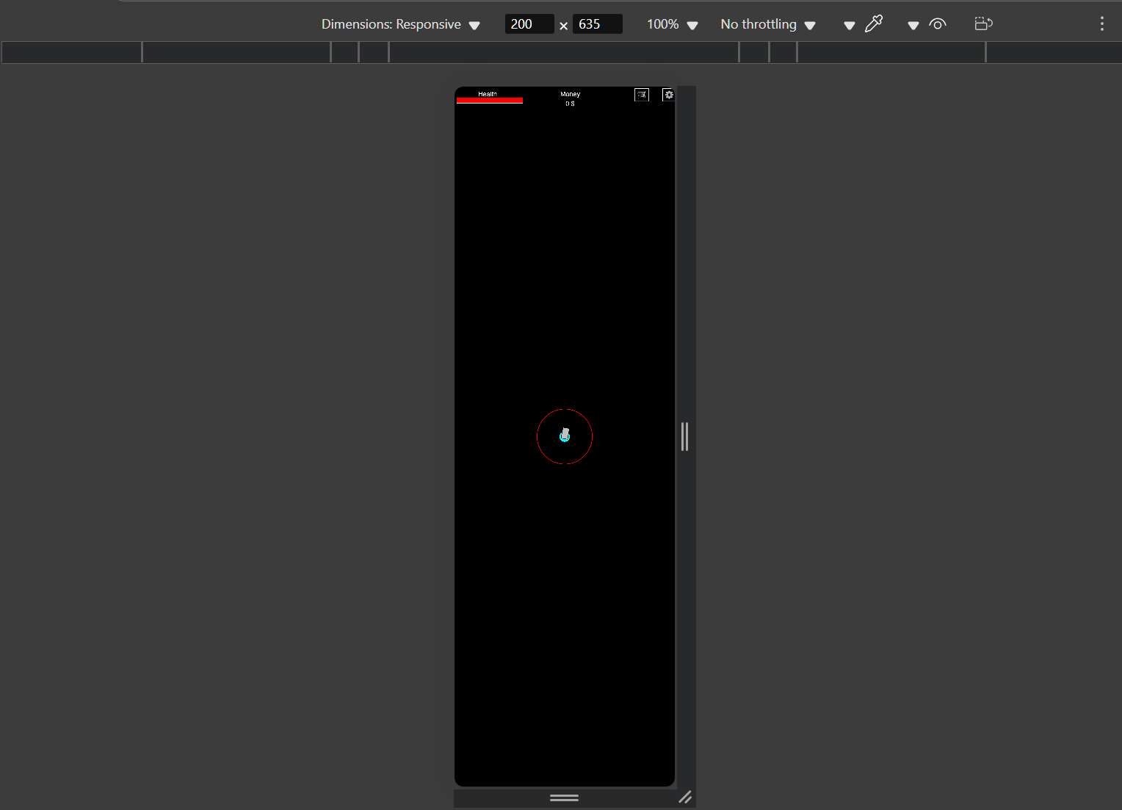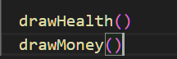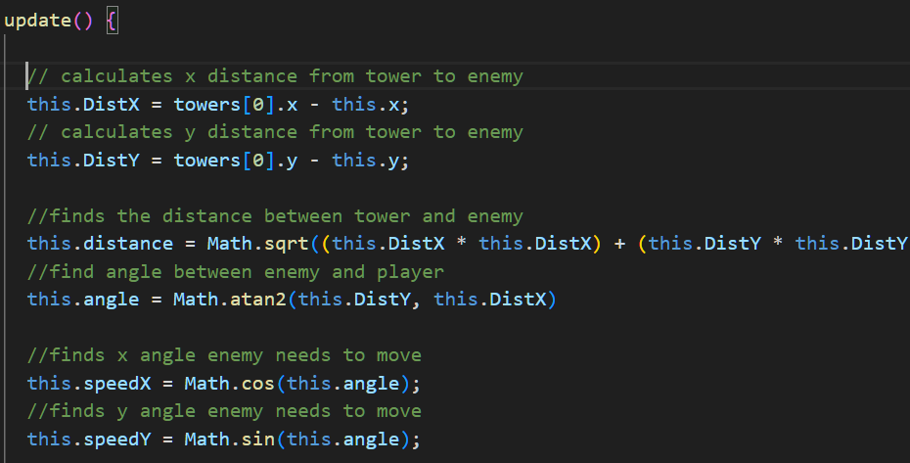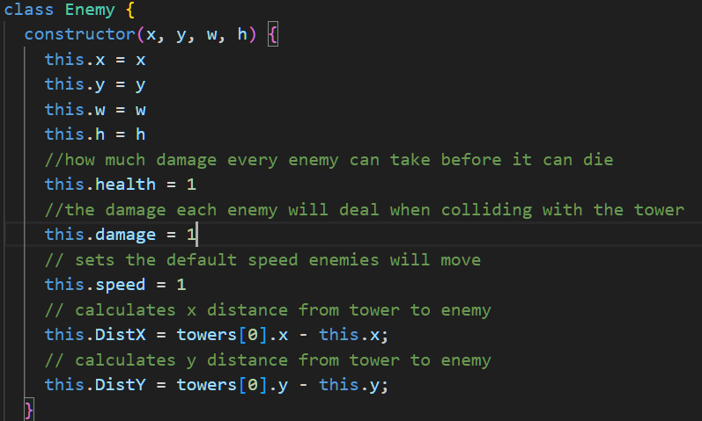
I updated the code to set the position to wherever the tower currently is on the canvas – perhaps I could add some further code later to this tower range update function when I start working on the upgrades section of the game.

Whilst I don’t really expect memory issues playing the game, the code does run unnecessarily whenever the screen is resized so let’s update the game only for when those object are needed to be resized based on the current game state the player is in.

Since this fixed most of the issues when resizing the screen, I basically have to now do the same for everything I have currently created since – the enemies need to relocate the tower once the screen changes as well as the other shop buttons UI I have made also require updating per screen size change.

So now that works let’s work on reformatting the other aspects of the game.

To fix the rendering of the menu objects similarly to the tower I would just have to reassign the buttons based on the window width and height and etc. Draw title could also be recalled to redraw the title with the new current window screen size. By multiply the window width or height by the decimal I could make sure the buttons appear at a certain point of the screen regardless of the screen size, I also applied this to the title for similar results.
Interestingly this does have a scenario when this doesn’t work – if the user changes the screen size before playing the game then plays the game the screen size doesn’t resize – only when the user resizes the screen again will it then be fixed, this is due to the logic on the left, therefore updateGame() should probably called always when the screen size is changed.
Similarly in the methods in game such as the buttons, text, health bar and etc, will use window width and height for screen scaling, I also used min and max since using window width and height can make the buttons end up being too small or large this will limit how large the display will be on the screen. Then using the inbuild developer tools I could test different screen sizes to see if this worked properly – to which it did after some refining.
Then, recalling previous draw methods are used to redraw the health and money to scale on the screen
When updating enemies I didn’t realise my calculations to make the enemy move towards the tower wasn’t within the update function therefore when update was called this just did not correctly path the enemies based on screen size change so I had to move this to update so the updated tower position can be used for enemies to move.
Here is a short demonstrating of this working:
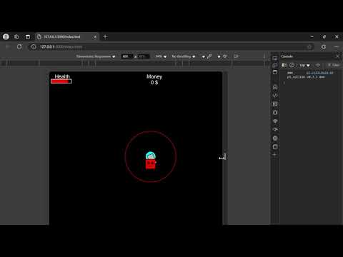

After some testing on different screen sizes, the game buttons modification previously didn’t seem quite right – as screen size increased, buttons could render beyond the screen making them of course not visible or they would overlap, instead, I iteratively went through a list of dimension to see what would look right and also be responsive to any screen.
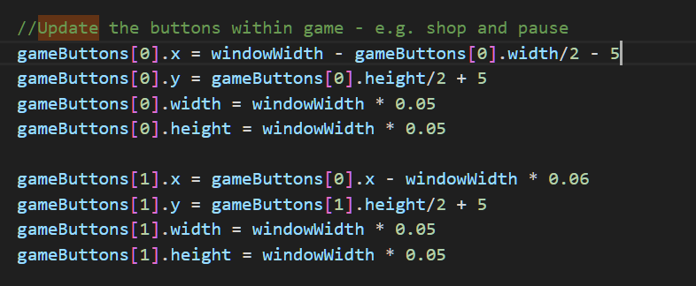
Instead if I adjusted the positioning of the buttons based on the width and height of the buttons then subtract or add it by the screen width and height I can ensure the buttons will always be within the current screen regardless of how large or small it is. For the cog button I wanted to position top right of the screen so achieve this I got the width of the button – the current screen width then a small offset so the button can be seen, similarly this was done with the shop button but the offset being the first button.
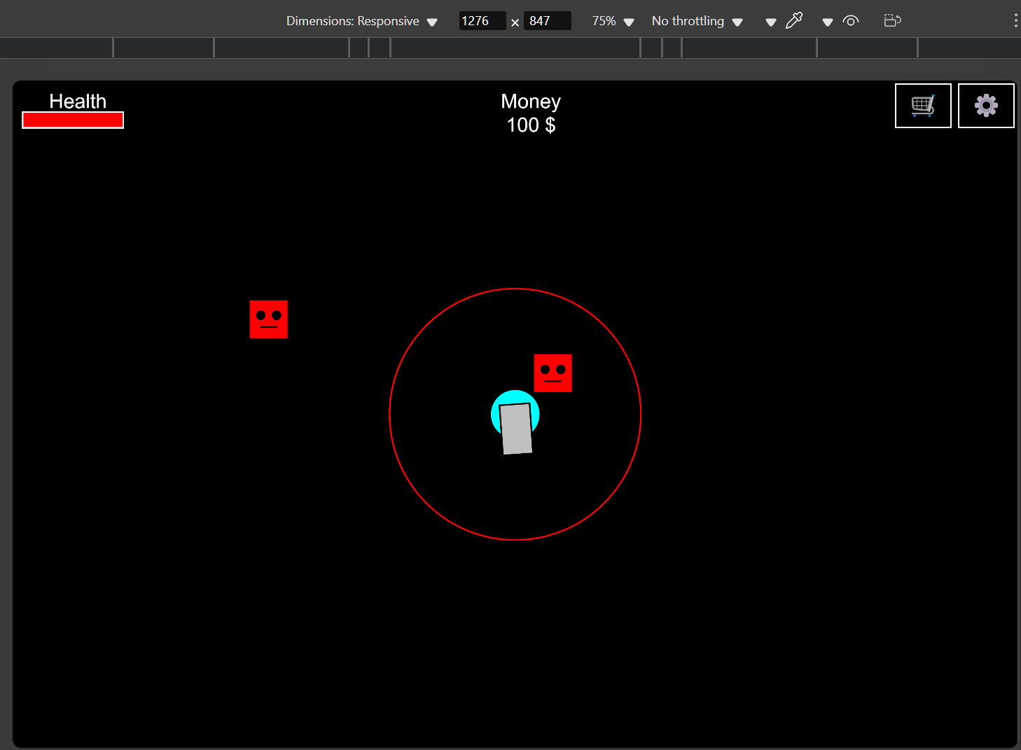
There seemed to be no issues this method allowing the game to be responsive regardless of screen size.

Miscellaneous Issues:
With screen size changes come with other changes such as game speed. On larger screen sizes, the game seemed to run slower since enemies and projectiles travel currently based on the screen size.

